VENANGO TECHNOLOGY CENTER
JOINT COMMITTEE
1 Vo-Tech Drive
Oil City, Pennsylvania 16301

MINUTES

January 3, 2022

The regular meeting of the Venango Technology Center Joint Committee was held this evening in the Conference Room of the Venango Technology Center, 1 Vo-Tech Drive, Oil City, PA 16301. Mr. Carson called the meeting to order at seven o’clock (7:00) p.m.

Mr. Carson asked the members to pause for a moment of silence.

Mr. Carson asked the members to stand for the pledge of allegiance.

Roll Call: Present: Shari Neely (zoom), Jeff Thomas (zoom), Mark Marterella, Andy Boland (zoom),
Ben Carbaugh, Todd Carson

Absent: Troy Johnston, Don Judy, Lynn Cressman, vacant Oil City position

Also Present: Mr. Mario Fontanazza, Mr. Kevin Briggs (zoom)

Lynn Cressman arrived at 7:01 p.m.

Mr. Carson stated the Joint Committee members had received copies of the Minutes of the December 9, 2021 meeting in the mail. He asked if there were any additions, corrections or deletions.

Mr. Marterella, seconded by Mr. Carbaugh, moved to approve the Minutes of the December 9, 2021 meeting as submitted.

Roll Call: Ayes: Shari Neely, Jeff Thomas, Lynn Cressman, Mark Marterella, Andy Boland,
Ben Carbaugh, Todd Carson

Nayes: None, motion carried.

The Treasurer and Secretary’s Report as of 1/3/22 were submitted for information.

Mr. Marterella, seconded by Mr. Carbaugh, moved to accept the Treasurer and Secretary’s Report as of 1/3/22 as submitted.

The motion was unanimously approved.

A list of bills from 12/10/21 – 1/3/22 in the amount of $658,379.28 was presented for approval.

Mr. Marterella, seconded by Mrs. Cressman, moved to approve the list of bills as presented.

Mr. Adams answered several questions regarding items on the list of bills.

Roll Call: Ayes: Shari Neely, Jeff Thomas, Lynn Cressman, Mark Marterella, Andy Boland,
Ben Carbaugh, Todd Carson

Nayes: None, motion carried.

Under Communications, Mr. Fontanazza discussed the Professional Advisory Committee. He also discussed the Calendar of Events for the month of December and the Monthly Enrollment Report as of 1/3/22 were submitted.

Mr. Carson requested approval of the action items as presented. Item 8. a) ii.- vi. excluding i. (no changes) in one motion.

Mr. Marterella, seconded by Mr. Carbaugh, moved to approve action items ii.- vi. as follows:

- Approve additions to Occupational Advisory Committees.
- Appoint Tim Sennett, of Knox, McLaughlin, Gornall & Sennett as Solicitor of the Joint Committee for 2022 at a cost of $125.00 per hour.
- .Approve Adult Evening School Schedule for Spring 2022.
- Approve list of equipment for disposal.
- Approve Advertising for the Natural Resources instructor and the Practical Nursing instructor.
- Approve 2022-2023 Budget.

Roll Call: Ayes: Shari Neely, Jeff Thomas, Lynn Cressman, Mark Marterella, Andy Boland,
Ben Carbaugh, Todd Carson

Nayes: None, motion carried.

Mr. Fontanazza reviewed his Issues/Activities for December 2021.

Mr. Carson asked if there was any old business.

None was noted.

Mr. Carson asked if there was any new business.

None was noted.

Upon motion by Mr. Marterella, seconded by Mr. Carbaugh, the meeting adjourned at eleven minutes past seven (7:11) p.m.

Recorded by
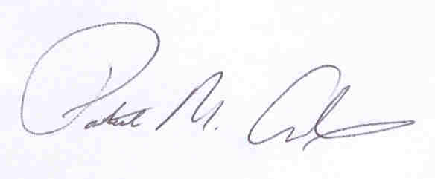
Patrick M. Adams
Secretary, Joint Committee

